Cosmos DB is ISO, FedRAMP, EU, HIPAA, and PCI compliant as well.

Azure Cosmos DB is a fully managed, globally-distributed, horizontally scalable in storage and throughput, multi-model database service backed up by comprehensive SLAs.

Create a container in data explorer of Cosmos DB

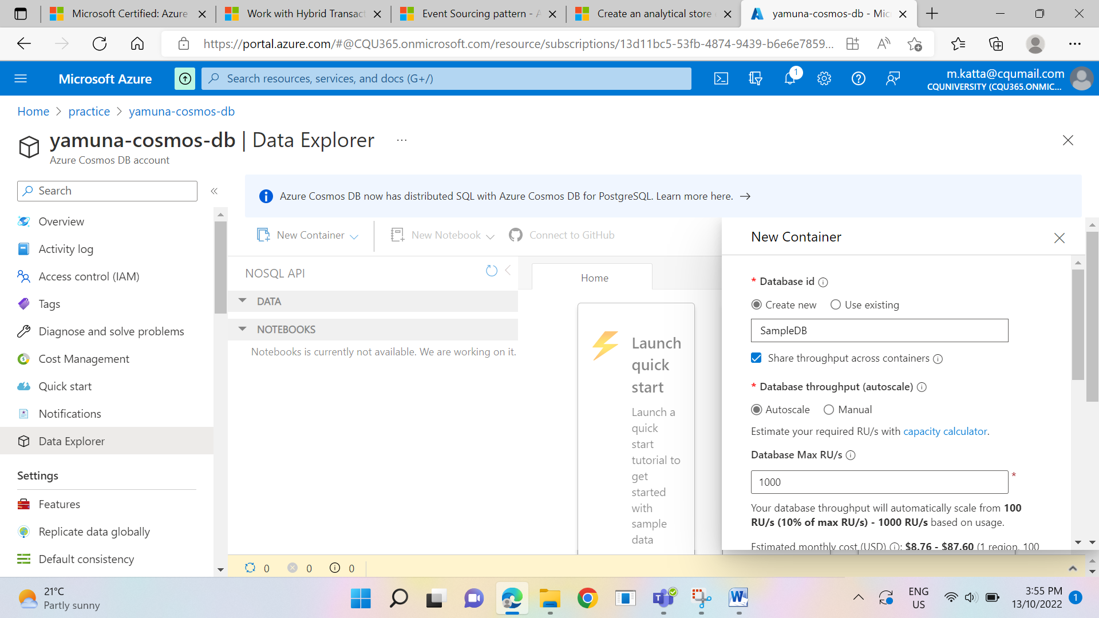

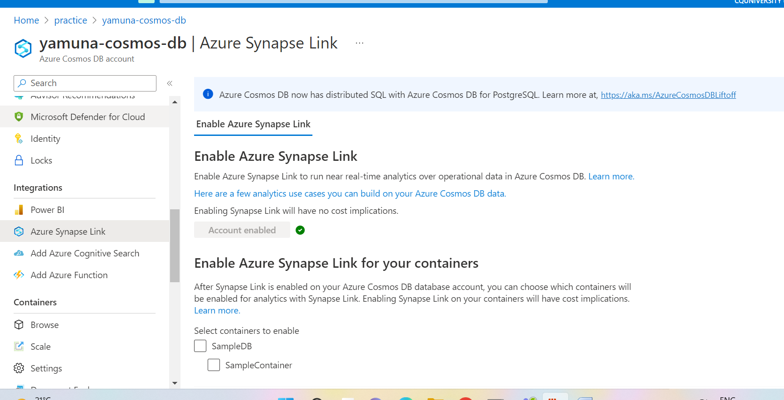

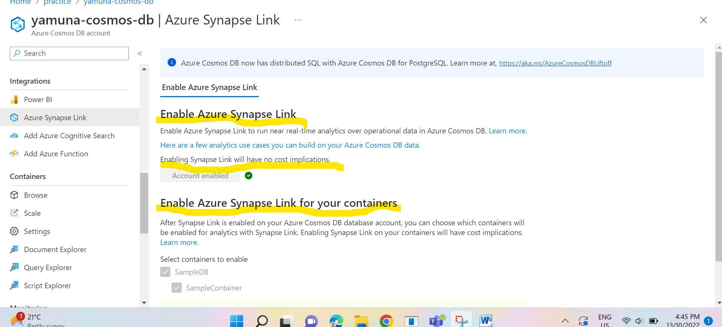

Azure Synapse is a limitless analytics service that brings together data integration, enterprise data warehousing, and Big Data analytics.

It gives you the freedom to query data on your terms, using either serverless or dedicated resources-at scale. Azure Synapse brings these worlds together with a unified experience to ingest, explore, prepare, manage, and serve data for immediate BI and machine learning needs.

Key service capabilities include:

* Unified analytics platform
* Serverless and dedicated options
* Enterprise data warehouse
* Data lake exploration
* Code-free hybrid data integration
* Deeply integrated Apache Spark and SQL engines
* Cloud-native HTAP
* Choice of language (T-SQL, Python, Scala, SparkSQL, & .NET)
* Integrated AI and BI

Managed resource group is a container that holds ancillary resources created by Azure Synapse Analytics for your workspace. By default, a managed resource group is created for you when your workspace is created. Optionally, you can specify the name of the resource group that will be created by Azure Synapse Analytics to satisfy your organization’s resource group name policies.

Optimized Autoscale is a built-in feature that helps Data Explorer pools perform their best when demand changes. You can choose to scale your Data Explorer pool manually to a specific instance count, or via a custom Optimized Autoscale policy that scales based on metric(s) thresholds. Optimized Autoscale enables your Data Explorer pool to be performant and cost effective by adding and removing instances based on demand

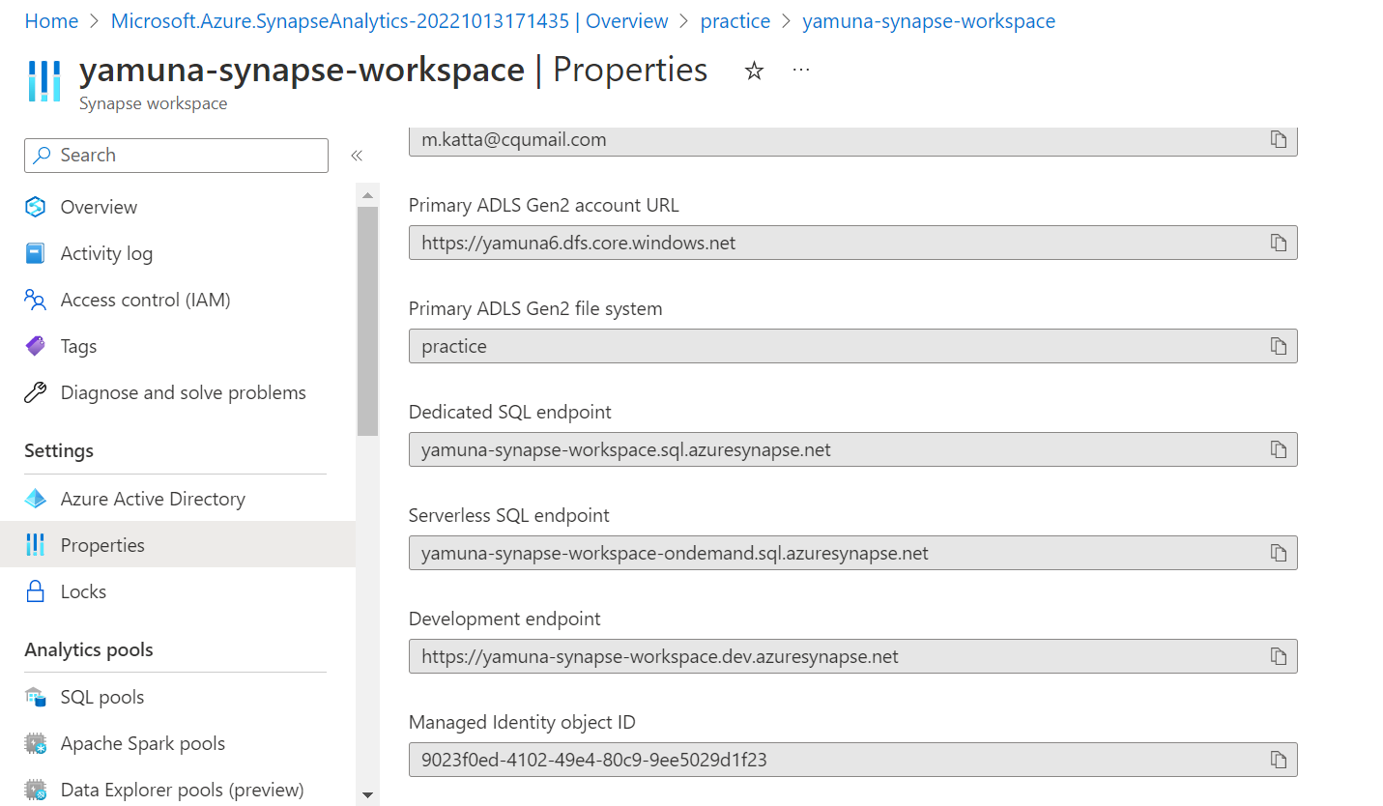

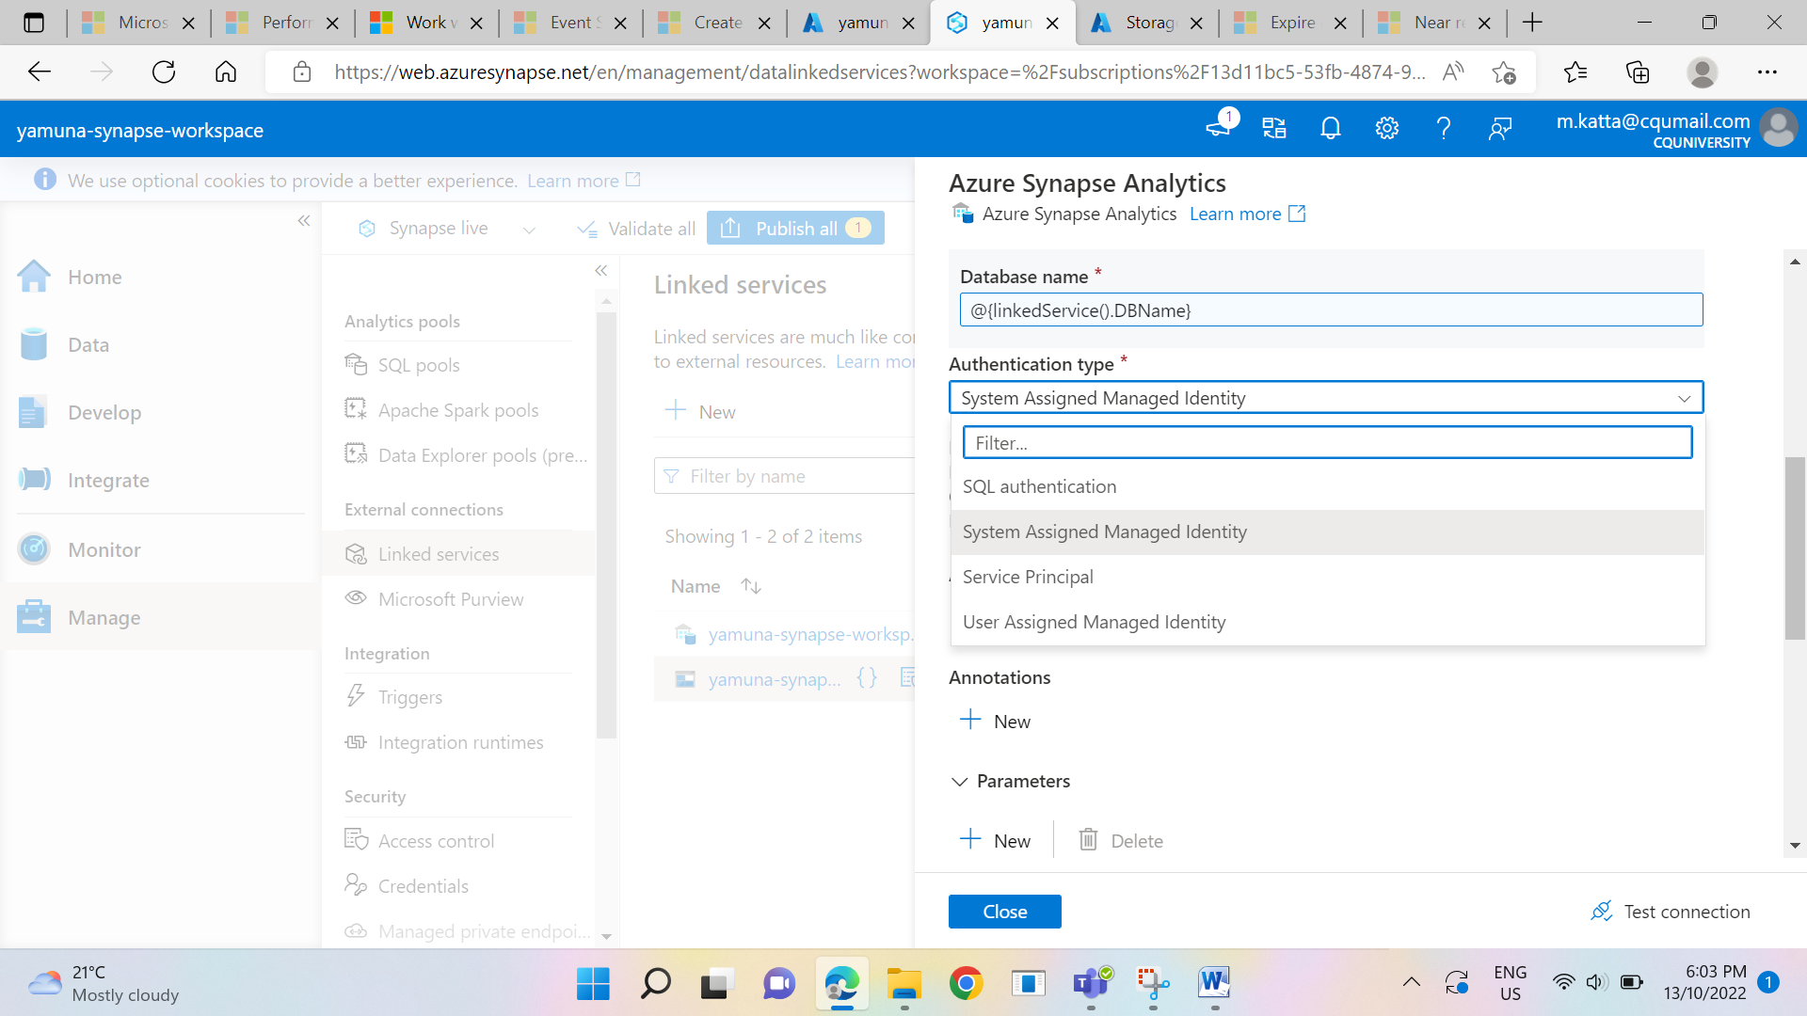

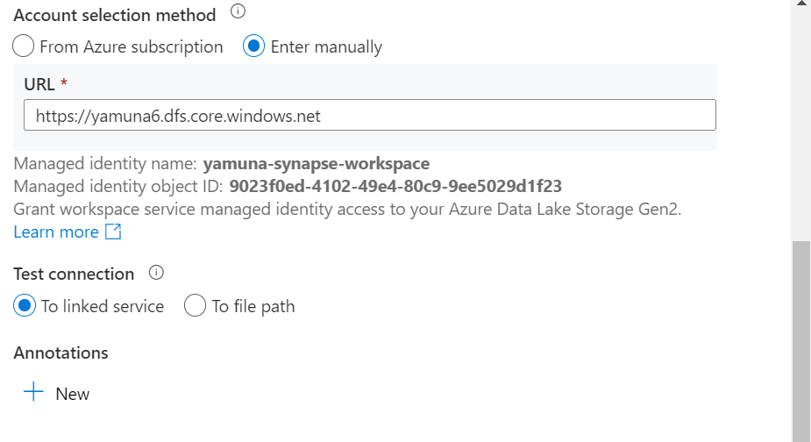

**SYNAPSE TO COSMOS DB LINKED SERVICE CONNECTION DETAILS:**

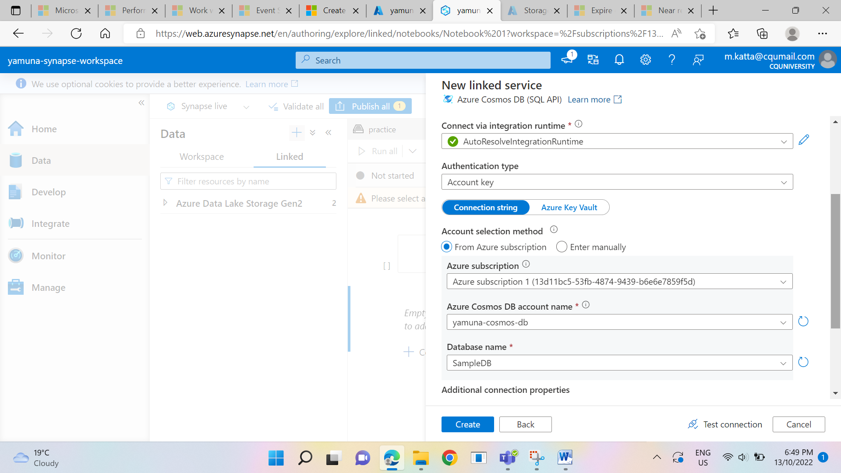

**LOADING COSMOS DB analytical data into a dataframe**

**df = spark.read**

**.format("cosmos.olap")\**

**.option("spark.synapse.linkedService", "my_linked_service")\**

**.option("spark.cosmos.container", "my-container")\**

**.load()**

**display(df.limit(10))**